For the Semester-II, Paper-IV; Prepared by Shri Koushik Barua, SACT, Department of History; Saheed Kshudiram College.
Emergence and spread of Islam in 700 CE
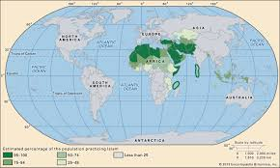
After Buddhism and Christianity, the third and last world religion is Islam that originated in 7th century CE. Interestingly, unlike its other two counterparts which took longer time to spread, Islam within few countries following its origin spread across the Asia, Africa and Europe. Several interpretations have been proposed to explain the rapid rise of Islam. For a long time scholars have attributed the militant zeal if Islam as the major factor leading to the rapid rise and expansion of Islam. Recent studies, on the other hand, criticizes such view and locate the rise of Islam in the peculiar socio-economic as well as geographical conditions of the Arabian peninsula playing a crucial role in the outgrowth and spread of Islam in the middle of first millennium CE.
Pre-Islamic Period:
The birth place of Islam, Arabian Peninsula, comprise some 1,250,000 square miles of area at present is divided into six countries Saudi Arabia, Kuwait, Bahrain, Qatar, United Arab Emirates and Oman. The entire peninsula was a sparsely populated arid zone largely embraced by desert and steppe. The peninsula was divided into najd (centre of Arabian peninsula), Al-Hijaz (Western Arabian peninsula), Yemen (south-eastern corner of Arabian peninsula) and Oman (South-eastern Arabian peninsula). Two of the important places linked up with early Islam Mecca and Medina were situated in Al-Hijaz which is also known as the birth place of Islam. The isolated oases in Al-Hijaz were the only places where sedentary life was possible due to the availability of water. The availability of water, hence, made possible some cultivation and animal husbandry in oases. Dates, some grains like wheat and fruits were grown here.
In pre-Islamic times, the Arabian population was divided into two main groups, one, nomadic tribes (qabila) known as Bedouins and second, settled communities. The beduins were constantly on move from one place to another. They were organized into different independent and autonomous tribe forms on the basis of common ancestor. The beeduin tribes were further divided into clans or extended families (quam). Pastoralism and raids were the chief means to generate resources of nomadic beduin. All the members considered each other as of same blood and beyond the commands of one chief (sheikh or shaykh) who invariably was the senior most member of the tribe. But, the chief was not the inviolable authority; he had to consult other senior members (head of families) in judicial, military and other important issues of common concern. The conception of private property was absent as they considered water, pasturage and cultivable land as the common property of the tribe. Camel was the substantive part of beduine life as was the only vehicles of transportation and medium of exchange. The camel was not only used as a vehicle to travel across the inhospitable Arabian desert but also was the source of milk to drink, flesh to eat, hair to make tent and dung for fuel. The settled communities engaged in cultivation, were often raided by them to augment their meager available resources. In some cases tribes were also collected from settled communities in return for protection by beduines. They spoke a form Semetic language which was a variation of Aramaic. Though there were different dialects but by the fifth-century CE a distinct Arabic linguistic identity had emerged which found expression in oral poetry called qasida or ode.
The beduin religion, in pre-Islamic times was centered on paganism. The various rituals, temples, idol-worship, and scarifies were the important features of indigenous cults famous among Arabian tribes. The beduin religious were basically animistic as several of natural phenomenon were conceived by them as divine or sacred. They also worshiped divine goddesses, solar and stellar cults, trees and stones. For example, the water of the Zamzam well, in Mecca, which is still considered sacred among Muslims, has roots in pre-Islamic pagan cults. Beduin’s life in demons (jinn) hostile to human life continued even after the advent of Islam. So is the case with the Ka ‘bah in Mecca which is believe to be originally built by Adam, and later rebuilt by Abraham and Ishmael. The Ka’bah in Mecca was the most famous pilgrimage site in pre-Islamic times in Al-Hijaz. The Ka’bah housed the block stone, a meteorite which was worshiped by the several beduin tribe who visited the Ka’bah shrine regularly. Besides being a religious centre in Mecca also involved in trade and commerce. Noticeable is the point that some of the tribes during 6th century had taken up trade; and abandoned nomadic life. Quaraish tribe of Mecca was one of such tribes which had adopted sedentary life style, and were engaged in trade.
In fact, the lengthy wars between Byzantine and Persians Empires made the western and Central Asian trading routes unsafe for the trade and commerce. Earlier the trading route through Iraq and Persian Gulf dominated the scene but due the Byzantine-Persian conflicts it was deserted. Thereby, there took place a shift in long distance trading network; and now Arabia emerged as a safer transit route for caravans between Africa and Asia. Some of the trade was directed towards Red Sea and some trade began on an overland trade route from Yemen to Syria via Mecca and Medina. Already famous as a religious centre the beginning of the caravan trade via Mecca further increased its prosperity and fame. The Quraish tribe, which was an aristocracy of traders and entrepreneurs, pre-dominated the affairs of Mecca’s religious as well as economic life. The prophet Muhammad, founder of Islam, was born in a family, belonging to Quraish tribe, in Mecca about 570 CE. Christian, Jewish and Zorostrian groups were also present were did not enjoy much influence among beduin tribe. The Jewish people were present in Medina, also known as Yathrib, and were engaged in agriculture. Medina was also situated on a trading route between Yemen and Syria. Yemen was another place where Judaism was well established.
Spread of Islam:
The credit for the emergence of Islam goes to Muhammad, whose father Abdullah and mother Aminah. Abu-Taalib, paternal uncle of Muhammad, looked after him as his parents died early. Muhammad at the age of 25 married to a rich widow, named Khadijah which brought financial surety to him. Along with his wife, Muhammad worked as a successful trader believed that angle Gabriel revealed the message of Allah to Muhammad which made him staunch monotheist and thereafter not only changed the course of Muhammad’s life but also of the entire world. Muhammad began to preach among his people and soon gained a considerable following in Mecca. The earlier convert includes his wife Khadijah, Cousin Ali, and Abu Bakr besides others. Muhammad criticized the polytheism prevailing in the Quraish society in Mecca. The Quraish tribesman soon become hostile as they thought that the teaching of Muhammad would deprived Ka’bah thereby Mecca, of its status of religious centre. The end of religious status would mean an end of economic prosperity due to the pilgrimage and related commerce. On the other hand, the people of Medina had no such concern and they invited him to stay in Medina. Hence, Muhammad finally moved from Mecca to Medina 622 CE along with his followers, and the event is known as the Hijrah. Later this event also became the starting point of Islamic dating system. Soon Muhammad established himself as the de-facto ruler of Medina and began to lead the raids on Quraish caravans. After several raids Muhammad was fortunate in capturing Mecca in 630 CE, after which the Quraish accepted his authority.
Following this the Ka’bah was declared as the scared shrine of Islam and gradually other beduin tribes also accepted the authority of Muhammad. Not all the tribes which submitted to the authority of Muhammad converted to Islam. Such tribes accepted to pay tribute in return of protection. Muhammad was declared as a prophet and the new faith was called Islam. The term islam means submission, and the doctrine of Islam preached complete submission to Allah, the supreme God. Muhammad declared the territory around Ka’bah haram and the entry of non-Muslims were prohibited in this territory. The religion advocated by Muhammad clearly displayed Christian and Jewish influences which also were supplemented by pre-Islamic pagan traditions. The new religion consented the existence of demons and angels as well as the idea of last judgment day when individuals will be judged according to their merits and demerits possibly due to the influence of Christianity. The holy book Koran was declared as the supreme source of religion as contained the revelation of Allah. Muhammad did not decline the Bible and held that Jesus Christ was one of the greatest of long line of prophets though he denied divinity of Christ. The absence of clergy in Islam designates to a possible influence of Judaism which also lacks institution of clergy.
Spread of Islam:
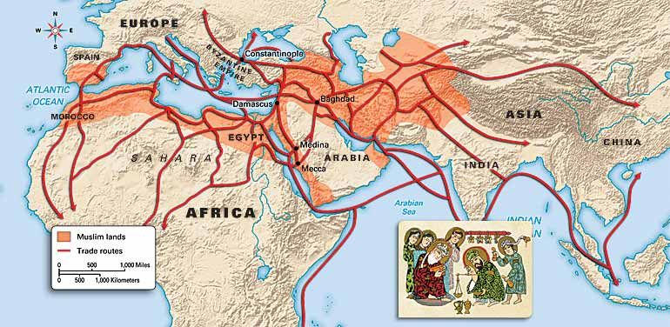

The biggest accomplishment of Muhammad was his ability to replace the tribe kinship as the basis of Arab social organization with a new bond of brotherhood based on faith. The tribal affiliations and older loyalties were now ceased and Arab now united under the banner of Islam as brothers. There was no priesthood and no hierarchy. Wine and gambling were abolished. Hence, Islam marked the end of paganism and beginning of an Arab unity which soon spread Islam beyond Arabian Peninsula. The death of Muhammad in June 8, 632 CE brought Abu Bakr, father-in-low of Muhammad, at the forefront who was now appointed caliph entailing i.e., ‘deputy of the prophet.’ It marked the beginning of the institution of caliphate that continued to dominate the Islamic politics for bout next three hundred years. The caliph was held as the political as well as religious leader of all Muslims. The first four orthodox caliphs- Abu Bakr (632-634CE), Umar (634-644CE), Uthman (644-656CE) and Ali (656-661 CE) were relatives as well as closely affiliated with Muhammad. The short caliphate of Abu Bakr witnessed frequent battles with Arab tribes which had become autonomous after the death of Muhammad. He was able to subdue the resistance of brought them under his authority; then, followed a period continuous wars and major conquests. Due to continuous struggles both Byzantines and Persians had exhausted to an extent that when Arab began their raids they failed to put any serious challenge. The Arabs conquered Byzantine Syria in 636 CE, entire Persia by 651 CE and Egypt 646 CE. Interestingly, the local populations of Byzantine and Persia was so over burdened with taxes that in byzantine lands of Syria and Egypt the inhabitants often welcomed Arab in against of the old rulers as the Arab demanded fewer taxes. In the beginning Arab did not force conquered population to convert and remained satisfied with the income in the form of taxes and tributes.
Pictures of Orthodox Caliphs
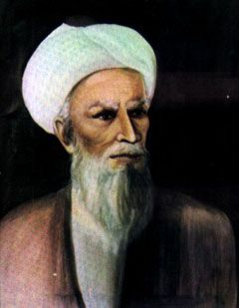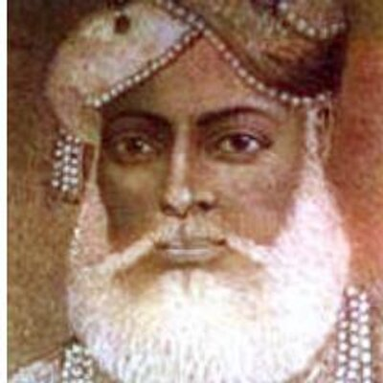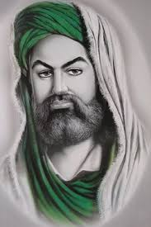

Abu Bakr Umar Uthman Ali

It is wrongly thought that the military characteristic of Islam motivated the Arabs to invade and establish their authority beyond Arabian Peninsula. In fact, it was the economic needs which drove the nomadic beduin tribes to conquer the land beyond the confines of their arid and unproductive land. In pre-Islamic stage the beduin divided into several tribes kept on fighting with each others for meager resources, but once they were united under a common authority of caliph search of new resources became essential. The very concept of Islamic brotherhood prompted them to unite for a common cause as it prohibited fratricidal combats. Initially their campaigns started as raids in the search of booty. But, when they found weak resistance on the part of Byzantine and Persian armies, they were motivated to capture the new fertile lands and demonstrate their authority. It resulted in the more systematic campaigns and ultimately in the establishment of Arab Empire. Therefore, it was the socio economic conditions of 7th century CE Arabian which created a favorable condition for the emergence of a new faith i.e., Islam, under the Prophet Muhammad. The dispersed beduin tribes were now unified under the banner of Islam and the leadership of caliph that constituted the army of faithful destined to rule a vast empire going around across Asia, Africa and Europe.
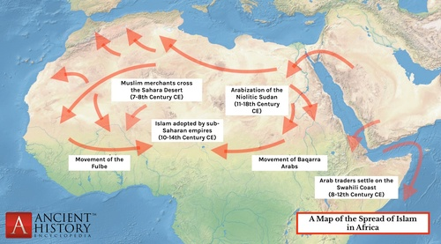
--------------------------------X----------------------------------

