Paper: VIII, Unit: IV

Mercantilism: Concept, Factors and Characteristics
In this article we will discuss about Mercantilism:- 1. Concept of Mercantilism 2. Factors Shaping Mercantilism 3. Main ideas or Characteristics 4. Critical Estimate 5. Decline.

Concept of Mercantilism:
The dominant system of economic thought that prevailed in Europe from 16th to 18th Century was Mercantilism. It was known by different names in different countries. In England it was called as commercial system or mercantile system because it emphasised the importance of commerce and free trade. It was also known as “Restrictive system” because its practical policies consisted of numerous restrictions and regulations on commerce.
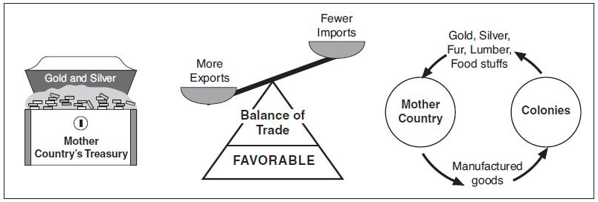
In France it was known as “Colbertism” after the name of Colbert, the Finance Minister of Louie the XIV. In Germany and Austria it was called “Cameralism”. It was also known as “Bullionism” because of the importance given to gold and silver.

Mercantilist thinkers did not form a group, advocating a fixed line of thought and policy. They were businessmen, merchants, administrators, in different countries. They left a number of pamphlets and papers regarding economic problems. Only the later economists have analysed their writings and found certain uniformity in their ideas and policies and have grouped them together as mercantilists.
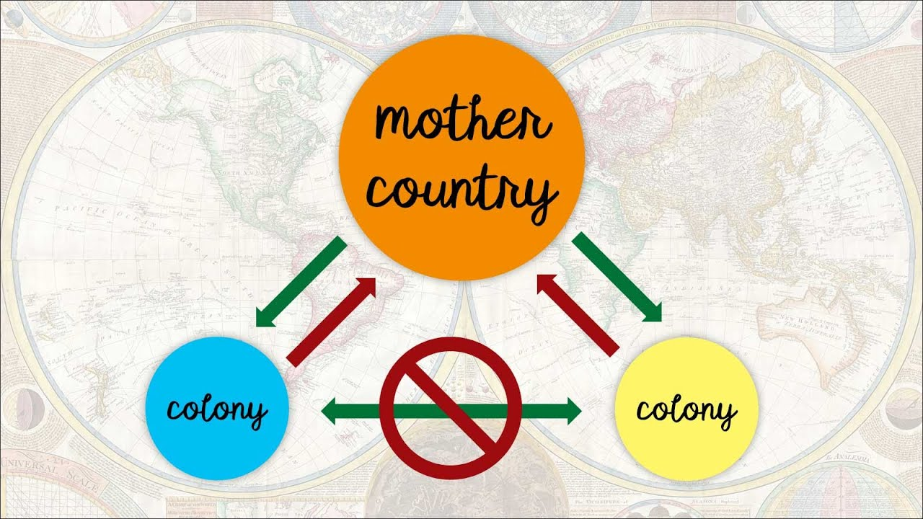
Mercantilism prevailed not only in England, France, Germany and Italy, but also in countries like Russia, Spain and Scotland. It adopted itself to the changing circumstances. Alexander Grey observed that “It had three hundred years run and so it coloured the thought and still more the actions of every country in Europe”. Haney says, “Mercantilism comprises the economic views that prevailed among the European statesmen from 16th to 18th century”.

Factors Shaping Mercantilism:
Some economic, political, religious and cultural factors were responsible for the emergence of mercantilism.

1. Economic Factors:
Towards the end of the 15th century changes were taking place in the economic life of the people. Domestic economy was giving way to an exchange economy. Agriculture was giving place to industry. Trade became very important and it changed the foundation of socio-economic set-up of the middle ages.
Trade necessitated the use of money which was available in the form of gold and silver. Along with the expansion of commerce there were improvements in transport, agriculture, population, etc., so the Mercantilist thought was the outcome of these developments.

2. Political Factors:
Towards the end of the middle ages nationalism became the strong force. Europe changed greatly due to Renaissance. As a result, there was a fundamental political change. It resulted in the emergence of strong nations like England, France, Spain, etc., Feudalism came to an end and the King became more powerful. Each nation wanted to preserve its independence and considered other nations as enemies. In order to create a strong and powerful state the Mercantilists tried to regulate the political and economic activities of the people.
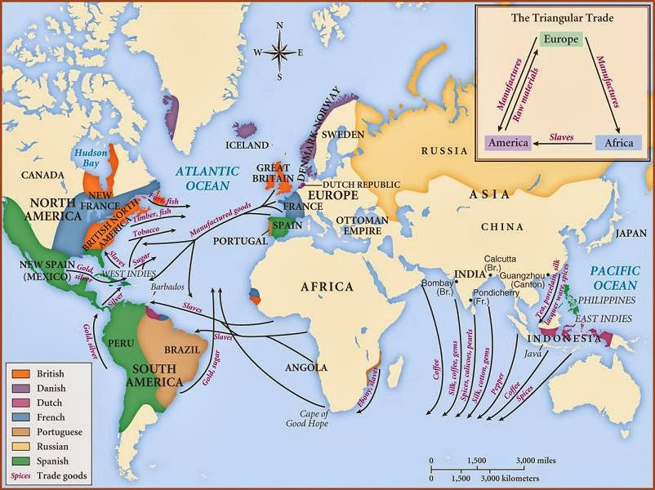

3. Religious Factors:
The Reformation Movement was revolt against Roman Catholic Church. It challenged the authority of Pope. Initially the Roman Catholic Church controlled the political and economic activities of the nation. But after the Reformation the authority of the Pope was challenged due to building of nation state.

4. Cultural Factors:
Culturally also Europe was undergoing a sharp change. Renaissance gave a new light of learning to the people. People were made to realise that this worldly life was more important than the heavenly life. So, lets’ enjoy the life and earn more money. As a result, money came to occupy an important place in human activities.

5. Scientific Factors:

In the field of science and technology great improvements and inventions were made. The discoveries of compass and printing press were of great importance, with the help of compass navigation became easier and it led to the discovery of new countries. Thus new countries opened the gates to a variety of raw materials and markets. The invention of printing press helped the spread of new ideas and knowledge.
6. Scientific inventions and Geographical Discoveries:
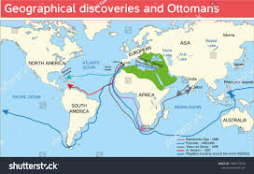
7. Industrialization and searching for new market :
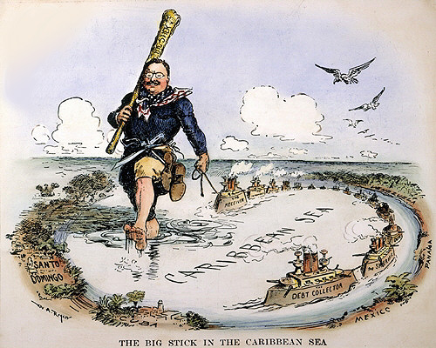
Thus all the above factors provided an atmosphere for the development of Mercantilist thought:
1. The fundamental aim of Mercantilism was to make a country strong. The strength of a country was tested with the help of the wealth of the country, above all, in that portion of wealth which consisted of precious metals like gold and silver. So the Mercantilists attached greater importance to bullion (gold) because it was the most durable, useful and generally acceptable form of wealth.
2. If a country has gold mines and silver mines, it can get gold and silver but if a country has no mines, it can get gold and silver through trade. The country should have a favorable balance of trade. In other words, there should be an excess of exports over imports.
3. In the Mercantilist system of thought trade was the most important occupation. Industry and commerce were ranked second in importance. Agriculture was the least important of all. The state had an important role to play in the Mercantilist system. It should come forward to exploit the natural resources of the country to increase its exports. There was regulation of economic life by the government.

Main ideas or Characteristics of Mercantilism:

1. Wealth:
The fundamental aim of the mercantilists was to make the country strong. The strength of the country was found in the wealth of the country, especially that portion of wealth which consisted of precious metals like gold and silver.
Mercantilism firmly believed that gold was the basis of wealth and power. Hence the mercantilist slogan was ‘more gold, more wealth and more power’. All the economic activities in the country were centred around wealth. According to Gray, “Everybody thought that his country was engaged in a race with other countries and in that race it must not be the looser”.
In this respect it seems that the mercantilists should have drawn inspiration from their predecessors because in ancient Greek and Roman and throughout the middle ages power was considered to be synonymous with accumulation of treasure or precious metals. Commerce was also encouraged on the same ground. To quote Columbus “Gold is a wonderful thing; whoever possesses it, is a master of everything he desires; with gold one can get souls into paradise”.
This greatest importance given to precious metals may be attributed to the following reasons:
ADVERTISEMENTS:
(i) In the 16th century, the only form of wealth, most useful and generally acceptable was gold and silver. Naturally the mercantilist attached more importance to gold and silver.
(ii) With the rise of absolute monarchy, taxation could be possible only if money was used as measure of value. Thus on the political side also money came to occupy greater importance.
(iii) For conducting wars money was essential. Three things were required for war—money, more money and still more money.
(iv) Mercantilists believed that trade depended on plentiful of money.
ADVERTISEMENTS:
(v) Money was also needed for development of exchange economy.
(vi) Money in those days was identified with capital.
Thus the Mercantilists had a high regard for money. If we consider the circumstances of the day, Mercantilists were justified in attaching greater importance to gold. According to Keynes, “the Mercantilists understood the important role of money in the economic system. They studied the effects of an increase in the quantity of money on the price level and employment.”

2. Foreign Trade:
The Mercantilist theory of foreign trade is known as the balance of trade theory. The aim of this theory was to get large amount of precious metals. Foreign trade was considered to be the only Source for getting gold and silver. They believed that all those nations which did not possess their own gold and silver mines could become rich after getting gold and silver from foreign countries through trade.
ADVERTISEMENTS:
Sir Thomas Mun the greatest representative of Mercantilist declared that, “foreign trade ought to be encouraged, for, upon it hinges the great revenue of the King, the honour of the kingdom, the noble profession of the merchant, the supply of our poor, the improvement of our lands and means of our treasure”.
The mercantilists insisted that the value of export should always be greater than imports. In short, they advocated a favourable balance of trade. Hence they encouraged exports and discouraged imports. “Export more, import less and collect the balance in the form of gold and silver”, was the essence of this theory. Accordingly every exporter was considered to be a close friend of the state and every importer as an enemy.
However, the mercantilists theory of foreign trade has no validity in modern times. If every nation exports more, there would be an end to international trade. Further, the mercantilists did not distinguish between particular balance of trade and general balance of trade. By general balance of trade we mean balance of the country’s trade with other countries and particular country.
Further, the mercantilists were ignorant of the fact that favourable balance of trade cannot be maintained for ever because if gold comes into a country more and more, there would be inflation. Thus the mercantilist theory of foreign trade is not a correct one.

3. Commerce and Industry:
ADVERTISEMENTS:
The mercantilists considered commerce and industry as the most important branches of the national economy. They wanted to increase the national productive efficiency by means of regulation of industry and commerce. They believed, that commerce and trade were the most productive occupation and agriculture was the least productive.
Further, as they believed that manufacturing industries were more closely connected with commerce, they must receive all attention from the government. However, it should not be misunderstood that the mercantilists regarded agriculture as insignificant. They thought that agriculture did not contribute directly to the strength of the country.

4. Population:
Mercantilists encouraged large population for making the nation militarily strong and for increasing its productive capacity. They believed that cheap and abundant supply of labour would keep the cost of production low.
This would enable a country to sell its commodity at a lower price in the international market According to Davenant, “People were the real strength of a country”. The mercantilists even encouraged immigration because they would bring wealth and enrich the country.

5. Natural Resources:
The mercantilists wanted to utilize all the natural resources to the maximum extent so as to produce more, export more and import less. They also attached importance to agriculture in order to solve the food problem. Colonies were developed to supply the required raw materials. Further, the colonies were not allowed to export directly to foreign countries. All the commodities should be exported to the mother country only.

6. Wages and Rent:
The mercantilists discussed the problems of production only. So they did not give much importance to the problems of distribution, especially to wages and rent.

7. Interest:
No unanimity existed among the mercantilist writers on the subject of interest. Sir Thomas Mun, a famous mercantilist writer favoured interest taking for the loans on the ground that lending helped the poor and young merchants. It also led to the employment of the savings of the widows. Thomas Mun and his followers told that the rate of interest would be high or low depending upon the industrial conditions of the country.

8. Taxation:
The views of the mercantilists on taxation were interesting because they were more scientific and ahead of their time. Broadly speaking the mercantilists favoured a multiple tax system based on the principle of “each should pay according to the benefits received from the state”.

9. Theory of Value:
Regarding value, both subjective and objective approaches existed. Prior to the mercantilists, value was regarded as an intrinsic quality possessed by a commodity, it depended upon the utility of the commodity. Value was thus considered to be different from price. By the end of the mercantilist period, market value was recognised. Scarcity also determined the value of a commodity. According to the mercantilists the normal value of a commodity depended on the cost of production.

10. Factors of Production:
Mercantilists recognised three important factors of production, namely, land, labour and capital. Here we can quote Sir William Petty’s saying “Labour is the father and active principle of wealth as land is the mother”. The Mercantilists emphasised the cultivation of agricultural waste lands so that food production might increase and the country might become self-sufficient and imports might be reduced.

11. Commercial Regulation:
Mercantilists believed that commercial regulations were essential for maximising social welfare. Commercial laws were passed to restrict the import of food materials. But no regulation was applied to the import of raw materials because they were required for the industrial development of the country. The state supported the export industries and shipping which would secure a favourable balance of trade.

12. Role of State:
The mercantilists regarded the state as the supreme power for controlling the activities of the people. State was the master and its citizens, the servants. The mercantilists believed that state intervention was necessary to solve the problems of the society. They believed that for securing success in wars a strong nation was required.
Nearly, all the mercantilist writers believed that since the total economic resources of the world were limited, the economic policy must be framed in such a manner as to increase the power of the state. As a result they suggested the policy of protection.
The state policies were shaped according to this idea. Special acts were passed to encourage exports and the development of industries. Protection was given to the industries because their main objective was to maintain a favourable balance of trade.

12. Land Banking Schemes:
Mercantilists ideas regarding money gave rise to the establishment of Land Banking Schemes. Land Bank Schemes were introduced by Chamberlin and Barbon.

13. Occupation:
Mercantilists believed that merchants were the most profitable members of the society. To them occupation was productive only if it increased wealth of a country.

Critical Estimate of Mercantilism:
Mercantilist theories and practices have been criticised by many writers. The opposition actually started towards the end of the 17th century. The storm of criticism against mercantilism was particularly strong in France. The criticism against mercantilism reached its climax towards the end of the 18th century when Adam Smith published his book “The Wealth of Nations”, one fourth of which was devoted to this.
Broadly speaking, the following criticisms have been leveled against mercantilists and their policies:
(1) They gave too much importance to gold and silver and neglected the importance of other commodities.
(2) They exaggerated the importance of commerce and undermined the usefulness of agriculture and other branches of human history.
(3) They were wrong in believing that a favourable balance of trade was the only source of prosperity.
(4) Their belief that the gain of one nation was necessarily the loss of another was wrong.
(5) Their ideas regarding ‘utility’ and ‘value’ were vague and abstract.
(6) Their ideas about capital and interest were imperfect.
(7) They lacked broad-mindedness.
But at the same time, we should not completely criticize the mercantilist doctrines and theories. While studying their ideas, one should not overlook the circumstances and problems of their times. Mercantilism was essentially a product of its age. It is no doubt true that they erred at places. But as Haney has remarked “they are far from a mass of absurdities”. Thus the mercantilist system had its own weaknesses.
As an economic policy it lacked universal application. As a body of doctrines, it could not provide right guidance to statesmen of the time. They confused the means and the ends by overemphasizing the importance of bullion. Further, in their zeal to increase the total productivity of the nation, they regarded wealth and labour as the ultimate goal of human existence.
Mercantilists were not only practical administrators and traders, they also put forward such ideas which led to the development of various economic theories in modern times. Dr. Smith has rightly pointed out, “It is the mercantilists and not Smith, who are the spiritual predecessors of modern economics”. Mercantilism implied a general view of society which is often overlooked. They developed a sort of macro-economic approach to the problems of the society.
The mercantilists emphasised the need for maximising exports not only with the idea of accumulating gold and silver, but with the hope that a prosperous export sector would provide more employment. Even the emphasis of the mercantilists on more money can be justified on economic grounds. They were aware of the dynamic functions of money.
An increase in the supply of money would result in lowering the rate of interest which would serve as an inducement to invest. Knut Wicksell developed his theory of interest with the mercantilist ideas as the basis. Keynes also admired some of the mercantilist ideas. The mercantilists were aware of the fact that money is not merely a medium of exchange but a store of value.
Keynes noted that the mercantilists were concerned with the economic system as a whole and they were interested in securing optimum employment of the resources. Keynes approved two mercantilist ideas – more money for business expansion and more money for lowering the rate of interest.
Mercantilism paved the way for many western nations for their transformation from ‘commercial capitalism’ to ‘industrial capitalism’. The mercantilists ideas are powerful even today. In the words of Eric Roll, “Down to the present day they all reappear from time to time in various guises as symptoms and weapons of economic conflict”.

Decline of Mercantilism:
Mercantilism declined due to many reasons. Under the influence of the teachings of Smith, policy of plenty began to replace the policy of power. The development of banking reduced the importance of bullion and coins. Further, the expansion of market economy showed that real estates, factories and machinery were more important items of wealth than gold and silver.
The economic growth that took place during the Industrial Revolution made the society to rely on competition. It was realised that the wealth of all nations could be increased simultaneously by efficient utilisation of natural resources and through the progress made in science and technology.

