Paper: III, Unit: III, C
Proliferation of castes during Early Medieval India
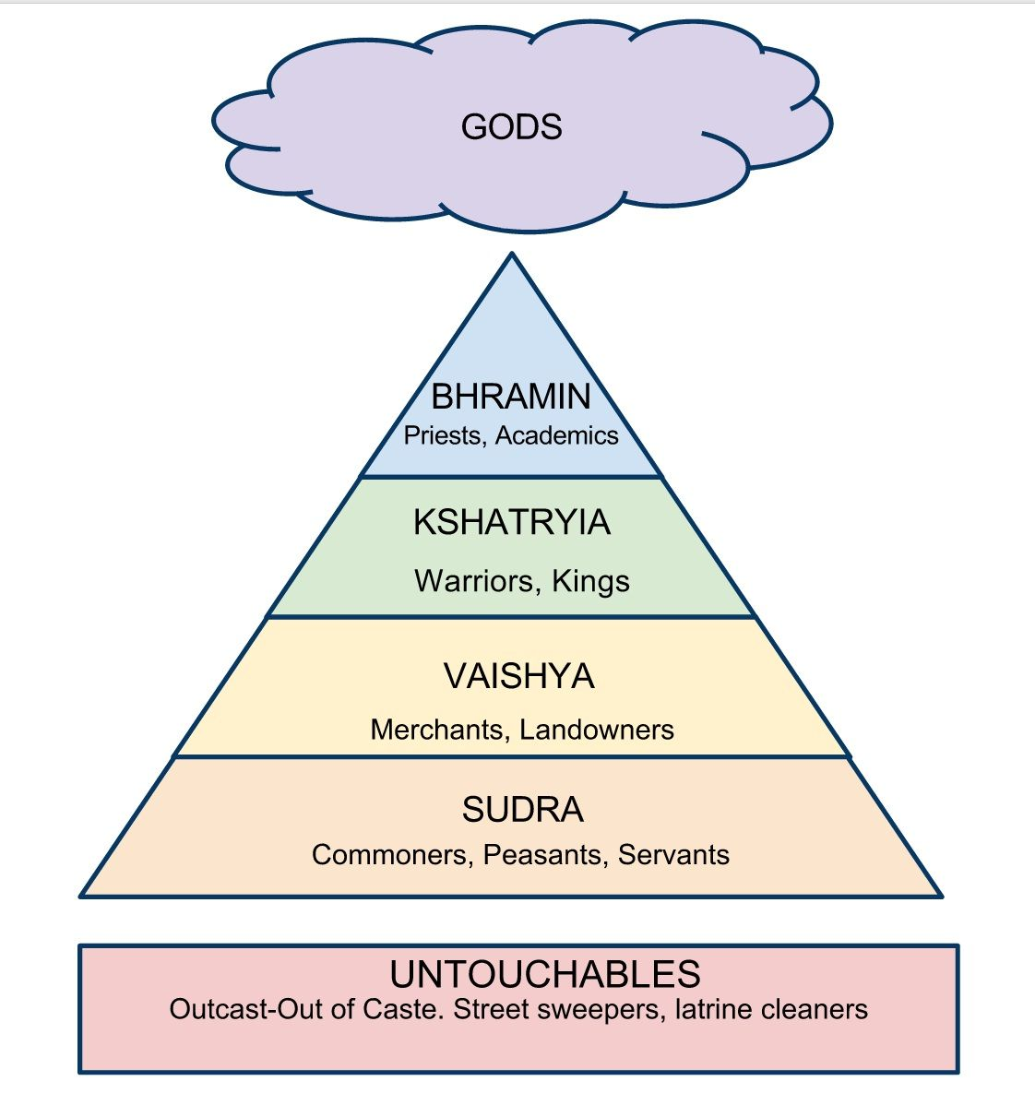

Reasons of numerous castes in early medieval India:
Increasing pride of birth, characteristic of feudal society, and the accompanying self-sufficient village economy, which prevented both spatial and occupational mobility, gave rise to thousands of castes in India during the early medieval Period.

The changes in economy were also a result of emergence of certain new castes and decline of certain old ones. For example, the constant transfer of land of land revenues made by princes to priests, temples and officials led to the rise and growth of the scribe or the Kayastha caste which damaged the monopoly of Brahmans as writers and scribes.
Similarly, the decline of trade and commerce led to the decline in the position of the Vaishyas. The process of proliferation and multiplication of castes was yet another marked feature of the social life of the period.

Many new communities, which are known to us by the generic term Rajputs, were also recognized as Kshatriyas during the period. The foreign elements, which could not be put in any three higher classes, were naturally designated as the Shudras.

The guilds of artisans gradually hardened into castes due to lack of mobility in post-Guptas times. The maximum affected people were the Shudra and the mixed castes.

Inter caste marriage :
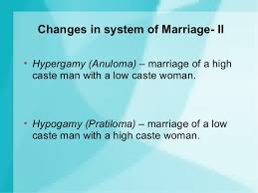
Ex: Chandal: Brahmni+ Sudra
Position of Brahmins:
The Brahmins stood at the top of the social hierarchy during and post Gupta period. They had regained their power and were responsible for reinterpreting the regulatory canons of life as laid down by the earlier texts.
However, Brahmins had numerous subsections now divided on the basis of many criteria such as knowledge of Vedas etc.
Getting birth in a Brahamin family was a privilege. Brahmins had freedom from death-sentence, exemption form taxes, precedence on the road, lesser punishment for certain offences in comparison with other castes. Many writers have documented the exemption of the Brahmans from capital punishment. The most severe punishment for a Brahmin was banishment (nirbasan). When a Brahman killed a man, the former had only to fast, pray and give alms. On the other hand, if somebody killed a Brahmin, he was ought to be greatest sinner and performed the worst crime. No punishment or remorse could wipe off the Brahman-hatya, the greatest crime of those periods!
Caste among the Brahmins: Variation in the status of the Brahmins Kouliyanaism by Ballal Sen in Bengal.

Position of Vaishya:
Vaishyas in the early medieval India were almost degraded to the Shudra community and became very closer to each other. In fact, Alberuni also did not find any difference between the Vaishyas and Shudra. If you are a Vaishya or a Shudra, and you dared to recite the Vedas, your ruler would cut off your tongue!

One difference was that the Shudra had freedom to sell all kinds of goods, but the Vaishya were forbidden to carry on transactions in some specified articles like salt, wine, meat, curds, swords, arrows, water, idols etc.

Position of Shudras:
Shudras were the most numerous sections in the community and their number increased from age to age. Some of the Shudras were regarded as mixed castes, born of unions of upper castes males with lower caste females or vice versa.
There were eight Shudra castes called “Ashtashudras” viz. Vyadha, Bhada, Kola, Koncha, Haddi, Doma, Jala, Bagatita, Vyalagrahi and Chandala.
However, there was another Shudra caste also whose position was lower then the above eight castes. These people were called the Antyajas. These Antyajas were beyond and below the the four orders and four Varnas of the Indian society.

Antyajas:
In the days of the composition of the early smritis, untouchables were called Antyajas. The Vedvyasamriti counts twelve names and includes all those who eat cow’s flesh as Antyajas.

Alberuni described eight groups of people, who were members of crafts and professions, but did not belong to the four-fold caste system, namely washerman, shoemaker, juggler, basket and shield-maker, sailor, angler, hunter of wild animals and birds, and weaver. These correspond to Rajaka, Charmakara, Nata or Sailushika, Buruda, Navika, Kaivarta, Bhilla and Kuvindaka, who have been regarded as Chandals and Antyajas in all early Smriti texts and as Shudras by Manu. Thus, they belonged to the lowest caste.
Rise of profession base caste system: Karmakar, Kumar etc.
Conclusion : We have to remember that the proliferation of the different castes was possible due to long socio-economic changes happened in Early Medieval India.

