For the Semester-I, Paper-IV, Unit-VI(a). Prepared by: Shri Koushik Barua, SACT, Department of History, Saheed Kshudiram College.

Societies in Central Islamic Land
THE TRIBAL BACKGROUND, UMMAH, CALIPHAL STATE; RISE OF SULTANATE
Caliphate under Umayyad:
The religious community that commenced to form in Mecca and then in Medina under the leadership of Muhammad, in the course of time led to the formation of first Islamic state, now Islam became the base of social organization. Allah was conceived as the personification of state supremacy, and prophet was seen as a legitimate supreme ruler presiding over the temporal realm on earth. After prophet, it was caliph who became spiritual as well as political leader of all the Muslims.

The Orthodox Caliphate (632-661 CE)
Once a vast territory was seized, next logical step was the organization of administration to consolidate the political authority. Caliph Umar was the first to take the task in his hand. Under him Arabian Muslims were given greater authority as they became the only citizens and rest non-Arabs were denied of citizenship. Even non-Muslims like Jews and Christians were expelled and driven out of Arab peninsular. Moreover, the Arab Muslims were forbidden from owning land outside Arabian Peninsula. The subjected population was left in their profession and allowed to own their land. They were considered inferior than the Arab Muslims in status and made to bear heavy taxes or tributes. All the Muslims were obliged to pay the zakat (poor rate), while non-Muslims had to pay jiziah (poll tax). The land tax was also collected from peasantry called kharaj. No radical change was introduced in Byzantine and Persian territories now occupied by the Arabs, and earlier form of administration was continued. All the income collected, was deposited in central treasury. After paying all expenses of administration and warfare, rest of the money was disbursed among the Muslims. But situation change during the caliphate of Uthman who allowed Arab Muslims to own land outside Arabian Peninsula which led to the emergence of landed Arab aristocracy. It is also detectable that the army was still organized in tribal units.

The Umayyad Caliphate (661-750 CE)
After the demise of Prophet Muhammad, a group in support of Ali (son-in-low of Muhammad), was formed demanding appointment of Ali as the Caliph. The demand was realized only after the death of third caliph Uthman who possibly was killed by one of the supporter of Ali. The group supporting Ali was known as the ‘legitimate’. This group believed that Ali was the legitimate successor if Muhammad chosen by both Allah and Prophet. Therefore Ali was cheated by first three caliphs who kept him out of his rightful office. Ali’s authority was challenged by Muawiyah, who was a kinsman of third caliph Uthmaan and governor of Syria. He charged Ali for the murder of Uthman. Muawiyah managed to keep his authority intact in Syria and after the murder of Ali assumed the place of caliph. The demise of Ali in 661 CE was the end of the orthodox caliphate which began with the accession of Abu-Bakr in 632 CE. The founder of Umayyad caliphate Muawiyah introduced the hereditary succession hence became the first Muslim king. In this way Umayyad caliphate was the first Muslim dynasty in the history of Islam. The centre of gravity now shifted away from Mecca and Medina as Muawiyah made Damascus, in Syria his capital which stayed on so till the end of Umayyad caliphate in 750 CE. The most significant event that took place during the Umayyad caliphates was the first major schism that took place in Islam. The supporter of Ali declared Ali’s son Al-Hasan, and after his death Al-Husayn as the caliph. On the other hand Muawiyah came afterby his son Yazid (in 680-683 CE) who sent his armies to crush th supporters of Al-Husayn. In the battle of Karbala Al-Husyan was killed. The event resulted in the division of Muslim community between two camps: one bearing the claim of the Umayyads, known as Sunni Muslim, and second supporting the family of Ali, came to be known as Shiah Muslims. After the battle of Karbala the division was further consolidated and still it is firmly rooted within Muslim community across the world. Yazid was followed by his son who failed to keep the authority in his hands; then, came Marwan (684-685 CE) who founded the Marwanid branch of Umayyad dynasty which established to be most successful. Marwan was followed by ‘Abd-al-Malik (685-705CE), Al-Walid (705-715 CE), Sulayman (715-717 CE), Umar (717-720 CE), Yazid II (720-724 CE), and Hisham (724-743 CE). Hisham was the last powerful ruler, who was accompanied by four weak rulers in quick succession.

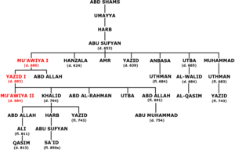

Under caliphateof Umar and Uthman Syria, Iraq, Persia and Egypt had already been conquered which marked the first phase of Arab conquest. The second phase began under the Umayyad, when Umaayyad armies one after another inhibited several of the regions and expanded their boundaries in west upto North Africa and Spain, and it east up to Transoxiana and Sind. The vast territory of Umayyad authority had several of linguistic groups like Greek and Pahlavi. To create a linguistic unity, the language of state administration was change to Arabic during the reign of ‘Abd-al-Malik and Al-Walid. The empire was divided into provinces looked after by a viceroy or governor who enjoyed complete control over political and military administration in his province. A bureau of registry was also created along with a state archive in Damascus. The work of his department was to look after and maintain record of each official correspondence. Earlier caliphs remained content with the indigenous coinage already in circulation of Byzantine and Persians. Therefore, the credit to introduce Arab coinage goes to Abd-al-Malik, who struck the first gold-coins (dinar) and silver coins (dirham) at Damascus in 695 CE. He also introduced regular postal service linking the capital, Damascus, with the provincial capitals. The non-Muslims had to pay higher tributes and comparison with Muslims who paid only zakat. As a result many people converted to Islam due to economic benefits. Several of new canals were also dug and old canals were restored in Iran and Persia to expand agriculture which was the major source of state income.

Yazid and his coins 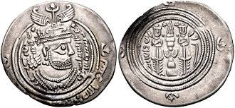

The Abbasid Caliphate (750-1258 CE)
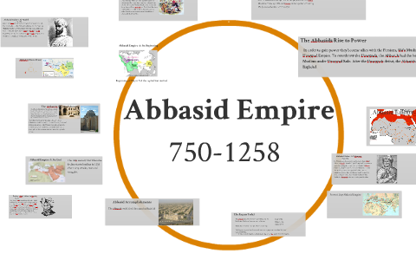
The last Umayyad king was Marwan II (744-750 CE) who failed to keep in check the increasing power of his antagonists and ultimately was killed on August 5, 750 CE. The challenge to Umayyad authority came from Abu-al-Abbas, who was a great grandson of Al-Abbas, the uncle of the Prophet Muhammad. With the end of Umayyad dynasty the centre of power shifted back to the east and Al-Kufah, on the border of Persiawas made a new capital. As a result Syria lost its political importance, so was the case with the cultural influence of Byzantine. Now Khurasanians and Persians gained greater influence on political matters under Anbbasid caliphates. The Khurasanians now formed the caliph’s bodyguard, while Persians were appointed an chief government positions.

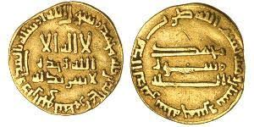
coins of Abbasid

In this way Abbasid caliphate brought an end of exclusive control of Arabian aristocracy over government. This resulted n an opening up of government offices for divers of nationalities. In this way where Umayyad caliphate was Arabic in character, Abbasid became an empire of neo-Muslims constituting various nationalities other than the Arabs. Moreover, for the first time caliphate was not conterminous with Islam, as was recognized by several of Islamic rulers like those of Spain and North Africa. The caliphs introduced their own administration and imitated Persian absolutism. They introduced lavish court ceremonies and became the patron of art, literature, and knowledge under Persian influence. Hence, under Abbasids Persian titles, songs, ideas, and thought gained greater importance. Only in two fields Arabic influence continued: one, Islam remained the state religion and second Arabic remained the state language. Al-Mansur (754-775) was one of the greatest Abbasid ruler who founded a new capital, Bagdad in 762 CE which subsequently became famous as a centre of not only political importance but also of cultural and economic activities. Soon the markets of Bagdad were flooded with the merchandises from china, India, Malay Archipelago, Central Asia, eastern Africa, Scandinavia and Russia.
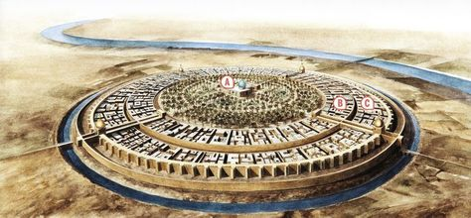

Al-Mansur also brought in the office of wazir, a Persian office, which enjoyed greater administrative authority subsequently. Important Abbasid administrative offices were:
- Account office- Diwan al-zimam,
- Board of correspondence- Diwan al-tawqi,
- Board of inspection of grievances
- Police department, and
- Postal department-Diwan al-barid.
The account office looked after the state income and expenditure, while board of correspondence handled all office letters. The board of grievances acted as a kind of court of appeal which was entrusted with a task to check the miscarriage of justice. Each city had a police department which was creditworthy for the maintenance law and governance in the city. The postal department had a special importance under Abbasid caliphate as this department not only linked the capital with different provincial capital but also maintained a well organized spy-network. The postal department as already mentioned was introduced under Umayyad caliph Muawiyah, but it was extended across the empire throughout the reign of abd-al-Malik, Al-Walid and Harun-al-Rasid. Under the Abbasis caliphate, merchants, peddlers, travellersand even women were appointed as detectives in espionage system. To look after the judicial department, a member of the theologian class was appointed as qazi. A qazi was a Muslim male, well versed in Islamic law. As it was under Umayyads, non-Muslims were allowed to be tried according to their own laws in civil matters. Moreover, the testimony of a Christian or a Jew was ruled do not to be ccepted against a Muslim in judicial matters.

The third Abbasid caliph, Al-Mahdi (775-785) declared the ‘holy war’ agaimst the Byzantines, which continued by his son Harun-al-Rashid (786-809). The Byzantine power was restricted forcefully under the Abbasids who now gained greater control over the several erstwhile parts of Byzantine Empire. Like umayyads, the department of finance the bureau of taxes (diwan-al-kharaj) proceeded to function as an important state department looked after by a state official. The main source of state income was zakat collected from all the Muslims. Kharaj and jiziah besides tributes from foreign enemies, and taxes levied upon the goods of non-Muslims traders or foreign merchandises were also the source of state income. The empire continued to be divided into [rovinces under the command of a governor (amir). An important change was introduced by Al-Muqtadir (908-932) who adopted the policy of farming out the provinces to governors or military officials instead of paying then in cash from imperial treasury. Even the soldiers were also started out to be paid in the form of land grants. It resulted in an increasing political authority and resources in the hand of governors who in several cases began to ruleas a e facto ruler subsequently. The increasing decentralization forcefully weakened the authority of Abbasid caliphs. After 945 CE, when Shiite Muslim group seized Bagdad, the Abbasid caliph was reduced to the position of a puppet. Then after, the Abbasid caliphate continued to rule in name, and was totally routed by the Mongols in 1258 CE. In this way the long period of caliphate beginning from Abu-Bakr, the first caliph to the end of Abbasids witnessed number of conquests and territorial expansions followed by organization of administrative-fiscal departments to govern the vast Islamic empire. A journey started from a small town of Medina, hence, culminated in the establishment of Islam as the most important political group and Arabic as one of the most popular political and cultural language of the medieval world.
Muslims ruled as that time

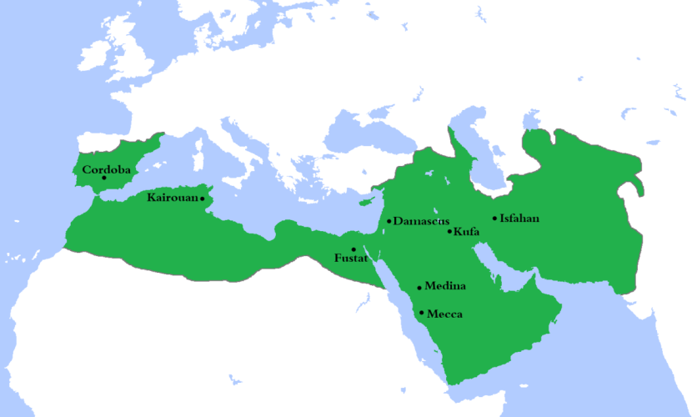

***Dynasty chart of Umayyad, Abbasid and Seljuk in Bengali version for better understanding in the next pages:

উমাইয়াদের বংশ তালিকা
উয়ামাইয়া

আবুল আ’স হারব
আল-হাকাম আবু সুফিয়ান
(৪) প্রথম মারওয়ান (১) প্রথম মাবিয়া
(২) প্রথম ইয়াযিদ
(৩) দ্বিতীয় মাবিয়া

মহম্মদ (৫) আবুল মালিক আব্দুল আযীয
(৮) দ্বিতীয় ওমর

(১৪) দ্বিতীয় মারওয়ান (৬) প্রথম ওয়ালিদ (৭) সুলায়মান (৯) ইয়াযিদ (১০) হিসাম

(১২) তৃতীয় ইয়াযিদ (১৩) ইবরাহীম (১১) দ্বিতীয় ওয়ালিদ মাবিয়া
আবদুর রহমান
আদ-দাখিল (স্পেন)
স্পেনের উমাইয়াগণ

আব্বাসিয়দের বংশ তালিকা
আল আব্বাস

(১) আল সাফ্‌ফাহ্‌ (৭৫০) (২) আল-মানসুর (৭৫৪)

(৩) আল-মাহদী (৭৭৫)

(৪) আল-হাদী (৭৮৫) (৫) আল-রশীদ (৭৮৬)

(৬) আল-আমীন (৮০৯) (৭) আল-মামুন (৮১৩) (৮) আল-মু’তাসিম (৮৩৩)

(৯) আল-ওয়াসিক (৮৪২) (১০) আল-মুতাওয়াক্কিল (৮৪৭)

সেলজুকদের বংশ তালিকা
(১০৫৫-১১৯৪ খ্রীঃ)

অম্বুজ
বাকায়িক
সেলজুক

মেকাইল পিন্ড আরস্‌লান (ইসমাইল)
কতলুমিন
চাগরীবেগ দাউদ (১) তুগ্রিল বেগ মহম্মদ (১০৫৫-৬৩) ইব্রাহিম নিয়াল সুলায়মান
রোমের সেলজুক
সুলতান বংশের প্রতিষ্ঠাতা
(২) আল্‌প আরস্‌লান (১০৬৩-৭২) কাওয়ার (কিরিয়ার সেলজুকগণ)

(৩) মালিক শাহ (১০৭২-৯২) (৪) তুতুশ (সিরিয়ার সেলজুকগণ)

(৫) বারকিয়ারুক (১০৯৪-১১০৪) (৬) মহম্মদ (১১০৪-১৭)

পারসিক ইরাকের সেলজুকগণ (১১১৭-৯৪)

তুগ্রীল (১১৭৭-৯৪)

